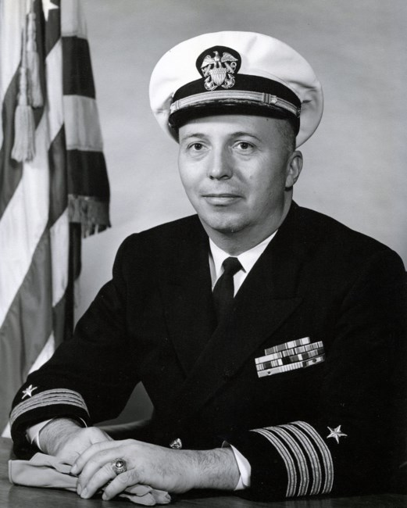
Franklynn Sperberg passed away on 4 February 2020. Captain Sperberg was born in Racine, Wisconsin. Prior to his appointment to the U.S. Naval Academy in June 1941, he was an undergraduate at Marquette University in Milwaukee, Wisconsin. As a member of the Seventh Company at the Academy he was active in track, lacrosse, the German Club and the Press Detail and graduated in 1944 with the Class of 1945.
His first duty upon graduation was on the USS RENO (CLAA-96) which was torpedoed near the Philippine Islands shortly after he reported on board. After almost a year of repairs the RENO made MAGIC CARPET trips bringing the troops back from Europe before it was decommissioned in 1946. Frank then joined the USS FALL RIVER (CA-131) as it served as the flagship for the Seventh Fleet and then later as the flagship for the target ships at the atom tests at Bikini. Between deployments of the FALL RIVER he married Mary Jane McCallum of Washington, DC in 1946. When the FALL RIVER went into mothballs in 1947, he entered the world of signals intelligence.
For the next 22 years he was involved principally with the application of machines and computers in a broad spectrum of COMINT and ELINT activities. Early tours found him at the Naval Security Station, Washington, DC, the Naval Computing Machine Laboratory, Minneapolis, MN and Officer in Charge of several shipboard communication units operating on a cruiser and destroyers. In 1951 while OIC for Communication Unit 38; he also served as Electronics Warfare Officer for COMNAVFE in Tokyo, Japan. In 1954 Frank earned a master’s degree in mathematical statistics at the University of Illinois, Urbana, IL. Returning to Washington, DC Frank had various tours at the Naval Security Station, the Armed Forces Security Agency, and the National Security Agency before being assigned as Officer in Charge of the Naval Security Group Activity, Sakata, Japan in 1958. On his return to the Naval Security Station, Washington, DC in 1960 one of his duties was Chairman of the Technical Operating Committee for Project Grab, the first successful US electronic reconnaissance satellite. This Naval Research Laboratory designed satellite was finally declassified in 1998 and the participants in the program awarded silver medallions in recognition of their efforts. From 1962 to 1965 he was assigned to the Office of the Secretary of the Air Force, Office of Space Systems for duty in the National Reconnaissance Office. His last Navy tour prior to retirement in 1969 was as the CNO Coordinator for Project BULLSEYE installing a worldwide network of radio direction finding stations.
Upon retiring from the Navy Captain Sperberg was employed in the Space Division, Lockheed Missiles and Space Company, Sunnyvale, CA. There he worked on various satellite programs as well as other diverse projects. Those programs ranged from information handling to designing a very high-altitude blimp. He retired in 1992 as a Consulting Engineer. As a Senior Member in the American Institute of Astronautics and Aeronautics, he has served as a member of that organization’s Lighter than Air Technical Committee.
Among his awards Captain Sperberg has received the Bronze Star, the Navy Meritorious Service Medal, and the Air Force Commendation Medal. He is a member of the Pi Mu Epsilon National Honorary Mathematics Society.
Since 1999 Frank lived in Williamsburg, VA. where he was active in the Presbyterian Church, in various Masonic bodies and with the Retired and Senior Volunteer Program. He is survived by his son, Robert, who retired as a Colonel in the Army Corps of Engineers and, one daughter Jeanne, six grandchildren, ten great grandchildren, and one great-great granddaughter. Mary Jane, his loving wife of 63 years, and a daughter, Patricia, have preceded him in death.

